Name: Namisha Singh

Lesson 5: Joins and Unions

1. Join the film to the film_actor table.

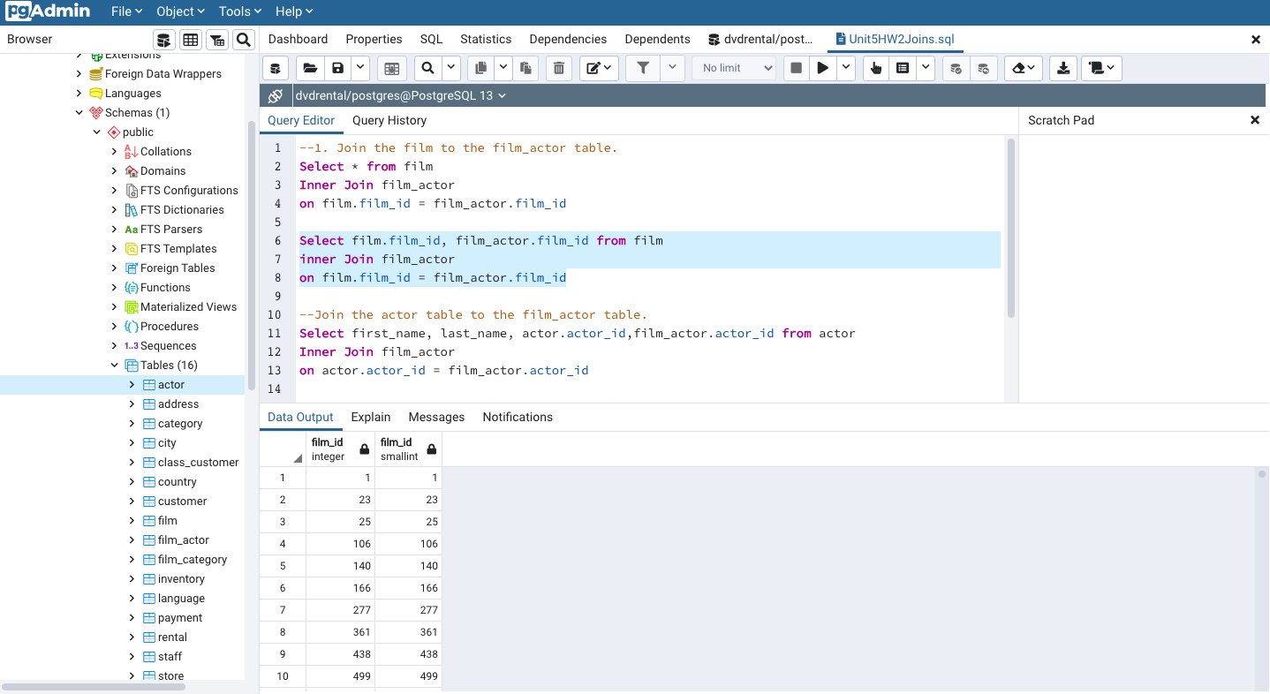

1. Join the actor table to the film_actor table.

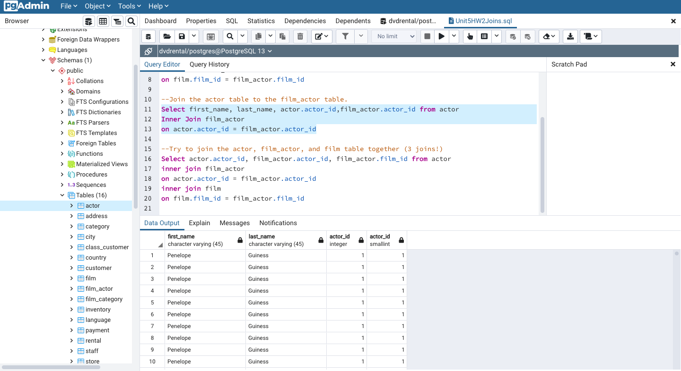

1. Try to join the actor, film_actor, and film table together (3 joins!)

